## Overview

Managing requirement plays a very important role in software project management. This feature allows project managers as well as members to keep track of their user requirements, specification documents.

OOPMS enables user to manage, trace and prioritize these requirement documents. Especially with CR management, BA and managers can easily control it.

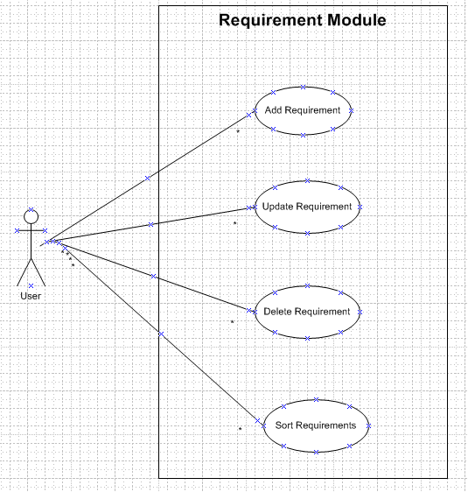

Requirement module overview

## Requirement Add

### Description

This function allow user to add new requirement.

### Use Case

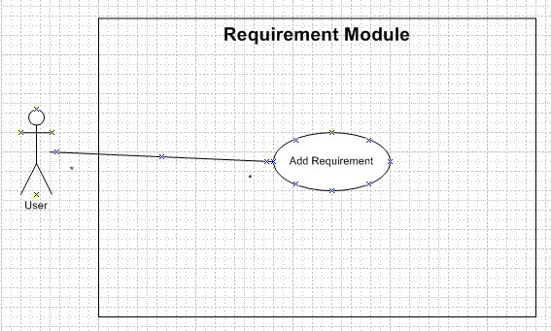

Add Requirement Use Case

### Use Case Scenario

|  |  |  |
| --- | --- | --- |
| User Case ID | Requirement _UC01 | |
| Name | Add Requirement Use Case | |
| Goal | This function allows user add new requirement or CR (Change Request). | |
| Actors | Project Manager | |
| Pre-conditions | Users must log in with role “Project Manager”; | |
| Post-conditions | N/A | |
| Main Flow | 1. Go to Requirement page. Click “Add” button.  3. Fill needed information and click “summit” button. | 2. Display page with required field for user to fill information.    4. Save requirement information. |
| Exception | N/A | |
| Open Issues | How to save requirement documents. (Link or database) | |
| Relationship | N/A | |
| Business rule | N/A | |
| Priority | 5 | |

## Requirement Update

### Description

This function allow user to update requirement.

### Use Case

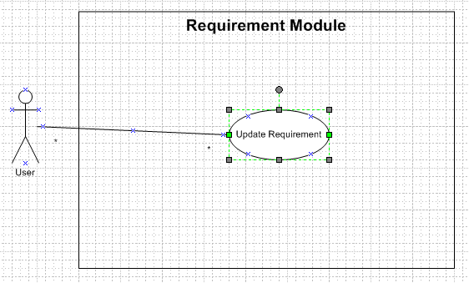

Update Requirement Use Case

### Use Case Scenario

|  |  |  |
| --- | --- | --- |
| User Case ID | Requirement _UC02 | |
| Name | Update Requirement Use Case | |
| Goal | This function allows user to update document, status. | |
| Actors | Project Manager, member | |
| Pre-conditions | N/A | |
| Post-conditions | N/A | |
| Main Flow | 1. Go to Requirement page. Choose requirement, Click “Update” button.  3. Fill needed information and click “Save” button. | 2. Display page with information for user to modify.    4. Save updated information. |
| Exception | N/A | |
| Open Issues | N/A | |
| Relationship | N/A | |
| Business rule | N/A | |
| Priority | 5 | |

## Requirement Delete

### Description

This function allow user to delete requirement.

### Use Case

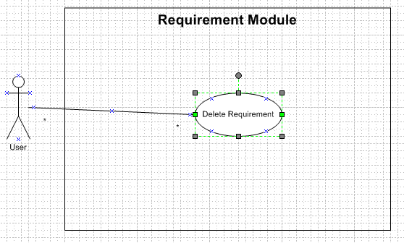

Delete Requirement Use Case

### Use Case Scenario

|  |  |  |
| --- | --- | --- |
| User Case ID | Requirement _UC03 | |
| Name | Add Requirement Use Case | |
| Goal | This function allows user to delete requirement. | |
| Actors | Project Manager | |
| Pre-conditions | Users must log in with role “Project Manager”; | |
| Post-conditions | N/A | |
| Main Flow | 1. Go to Requirement page. Choose requirement, Click “Delete” button.  3. Click “Yes” button. | 2. Display confirm box.    4. Delete Requirement. |
| Exception | N/A | |
| Open Issues | N/A | |
| Relationship | N/A | |
| Business rule | N/A | |
| Priority | 5 | |

## Requirement Sort

### Description

This function allow user to sort requirements.

### Use Case

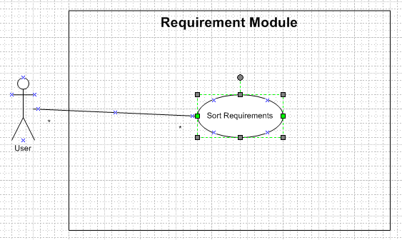

Sort Requirements Use Case

### Use Case Scenario

|  |  |  |
| --- | --- | --- |
| User Case ID | Requirement _UC04 | |
| Name | Add Requirement Use Case | |
| Goal | This function allows user to sort, filter requirement by Size, Priority or Date. | |
| Actors | Project Manager, member | |
| Pre-conditions | N/A | |
| Post-conditions | N/A | |
| Main Flow | 1. Go to Requirement page. Choose kind of filter (type, date, priority). | 2. Sort and Display new list. |
| Exception | N/A | |
| Open Issues | Sort by user and last modified? | |
| Relationship | N/A | |
| Business rule | N/A | |
| Priority | 5 | |